* **Backend**
  + **Database**

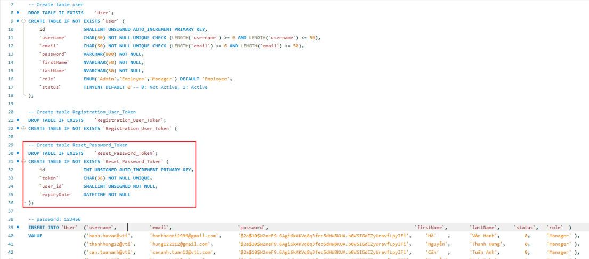

* + **Request reset password**

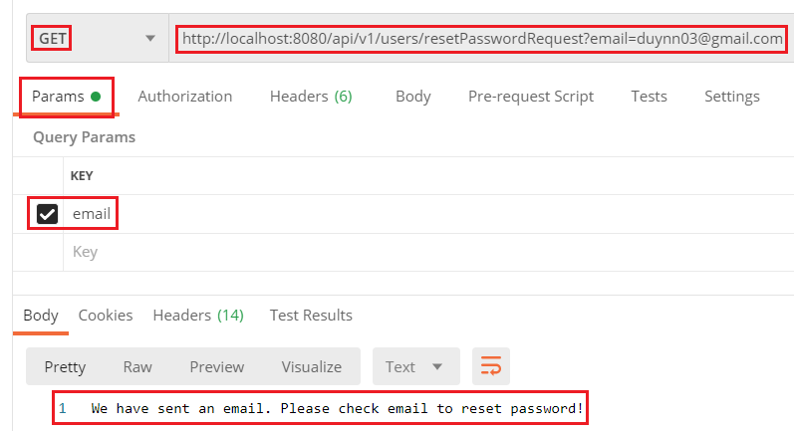

*Request reset password*

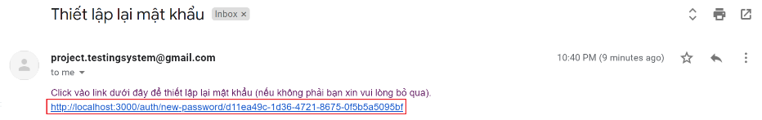

*Gmail*

* + **Reset Password**

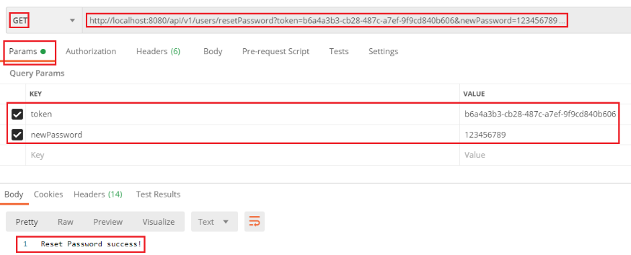

* **Frontend**

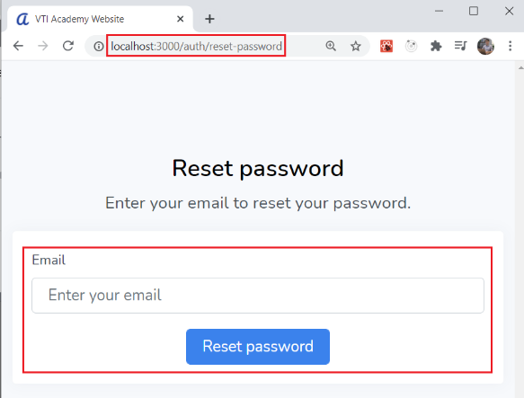

*Request Reset Password*

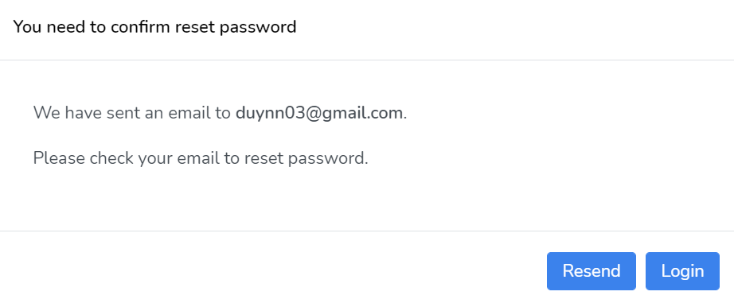

*Request successful*

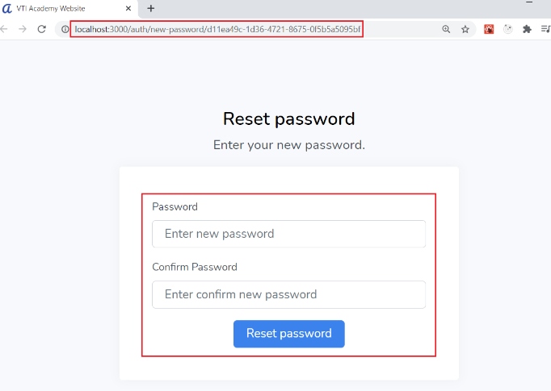

*Nhập new password (kèm token)*

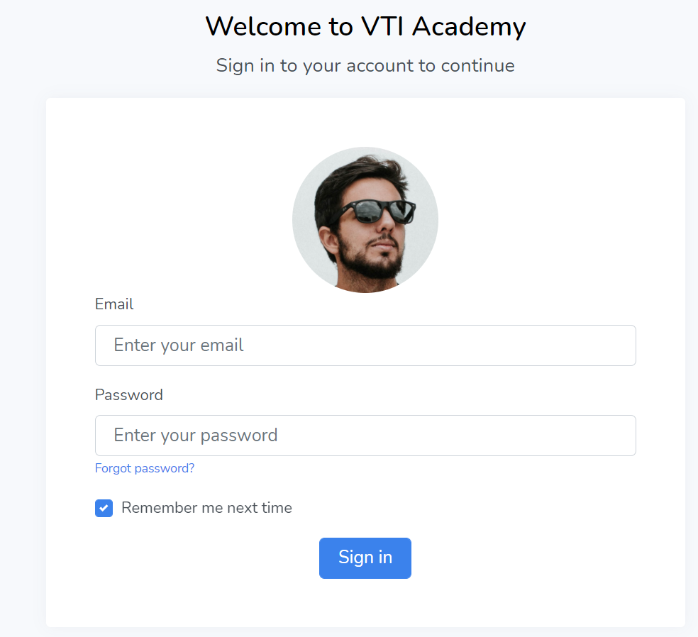

*Login page*

* **Reference**